IIFE FUNCTION

# Program 1:Print odd numbers in an array…

((*value*)*=>*{

  for (*let* i=0;i<*value*.length;i++){

          if(*value*[i]%2!=0){

                  console.log(*value*[i])

          }

  }

  })([11,22,33,44,55])

# Result:

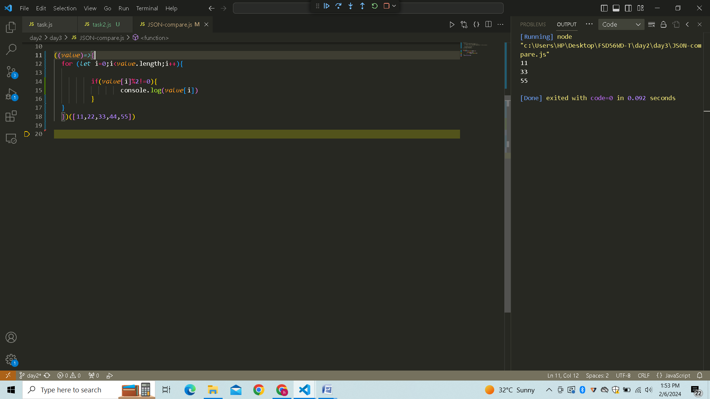

# Program 2: Sum of all numbers in an array…

((*value*)*=>*{

*let* sum =0;

    for (*let* i=0;i<*value*.length;i++){

           sum=sum+*value*[i]

    }

    console.log(sum)

    })([11,22,33,44,55])

# Result:

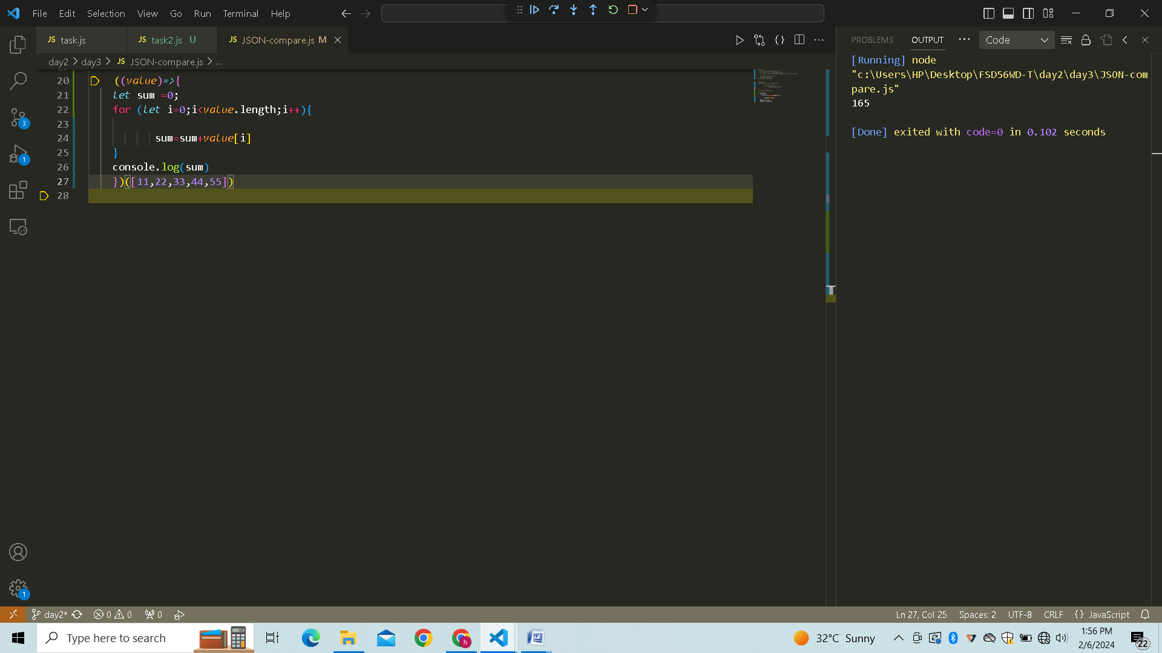

# Program 3: Convert all the strings to title caps in a string array…

((*str*)*=>* {

*str* = *str*.toLowerCase().split(' ');

    for (*let* i = 0; i < *str*.length; i++) {

*str*[i] = *str*[i].charAt(0).toUpperCase() + *str*[i].slice(1);

    }

*let* result= *str*.join(' ');

    console.log(result);

})("my name is harish")

# Result:

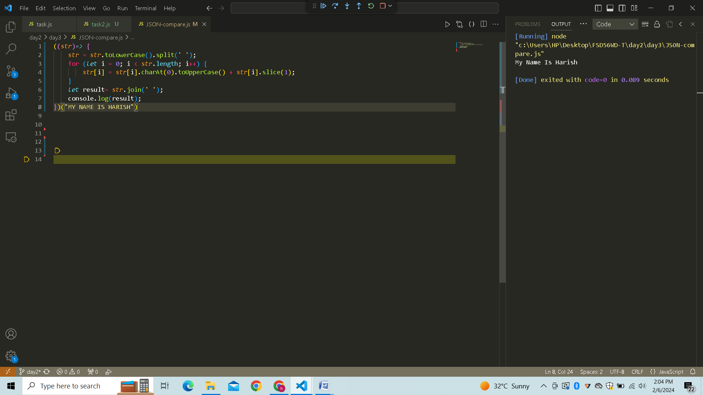

# Program 4: Return all the prime numbers in an array…

((*numArray*)*=>*{

*numArray*=*numArray*.filter((*number*) *=>*{

        for (*let* i=2 ; i <=Math.sqrt(*number*); i++){

            if (*number* % i==0)

            return false;

        }

        return true;

    });

    console.log(*numArray*)

})([1,2,3,4,5,6,7,8,9,10]);

# Result:

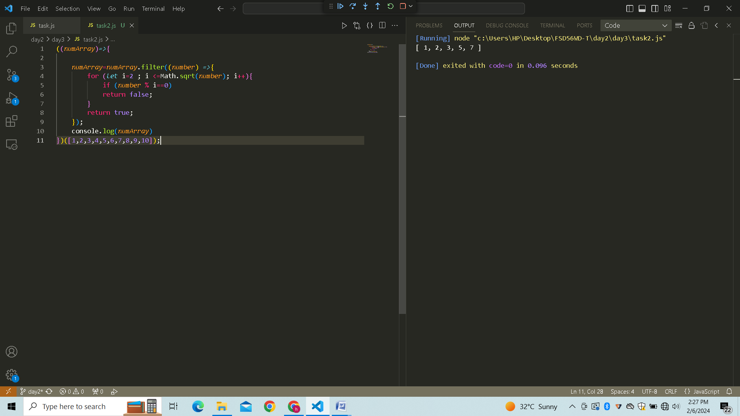

# Program 5: Remove the duplicate numbers in an array…

((*array*)*=>*{

*let* dup=[... new *Set*(*array*)];

    console.log(dup)

})([1,1,2,3,3,4,4,5,6])

# Result:

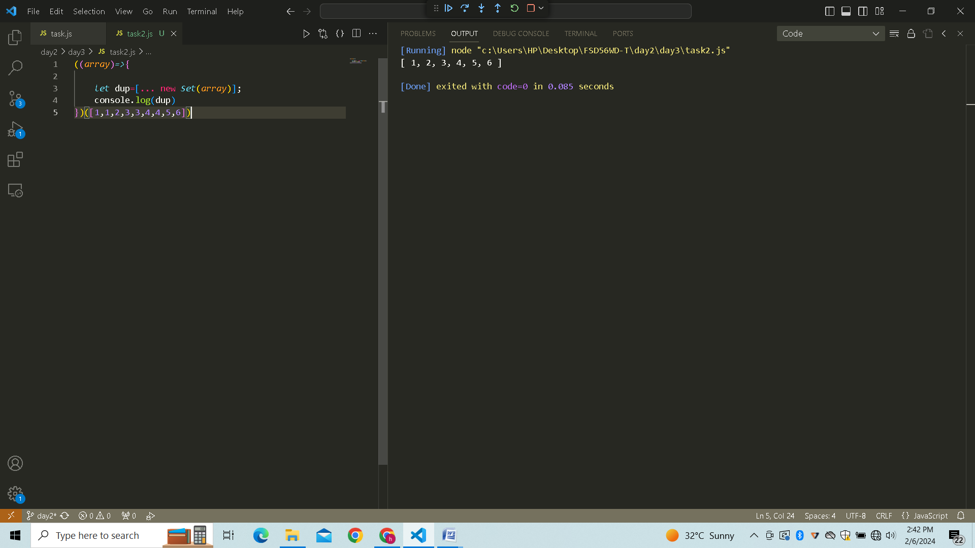

# Program 6: Rotate the array by n times…

((*nums*, *k*) *=>*{

    for (*let* i = 0; i < *k*; i++) {

*nums*.unshift(*nums*.pop());

    }

    console.log(*nums*);

})([1, 2, 3, 4, 5], 2);

# Result:

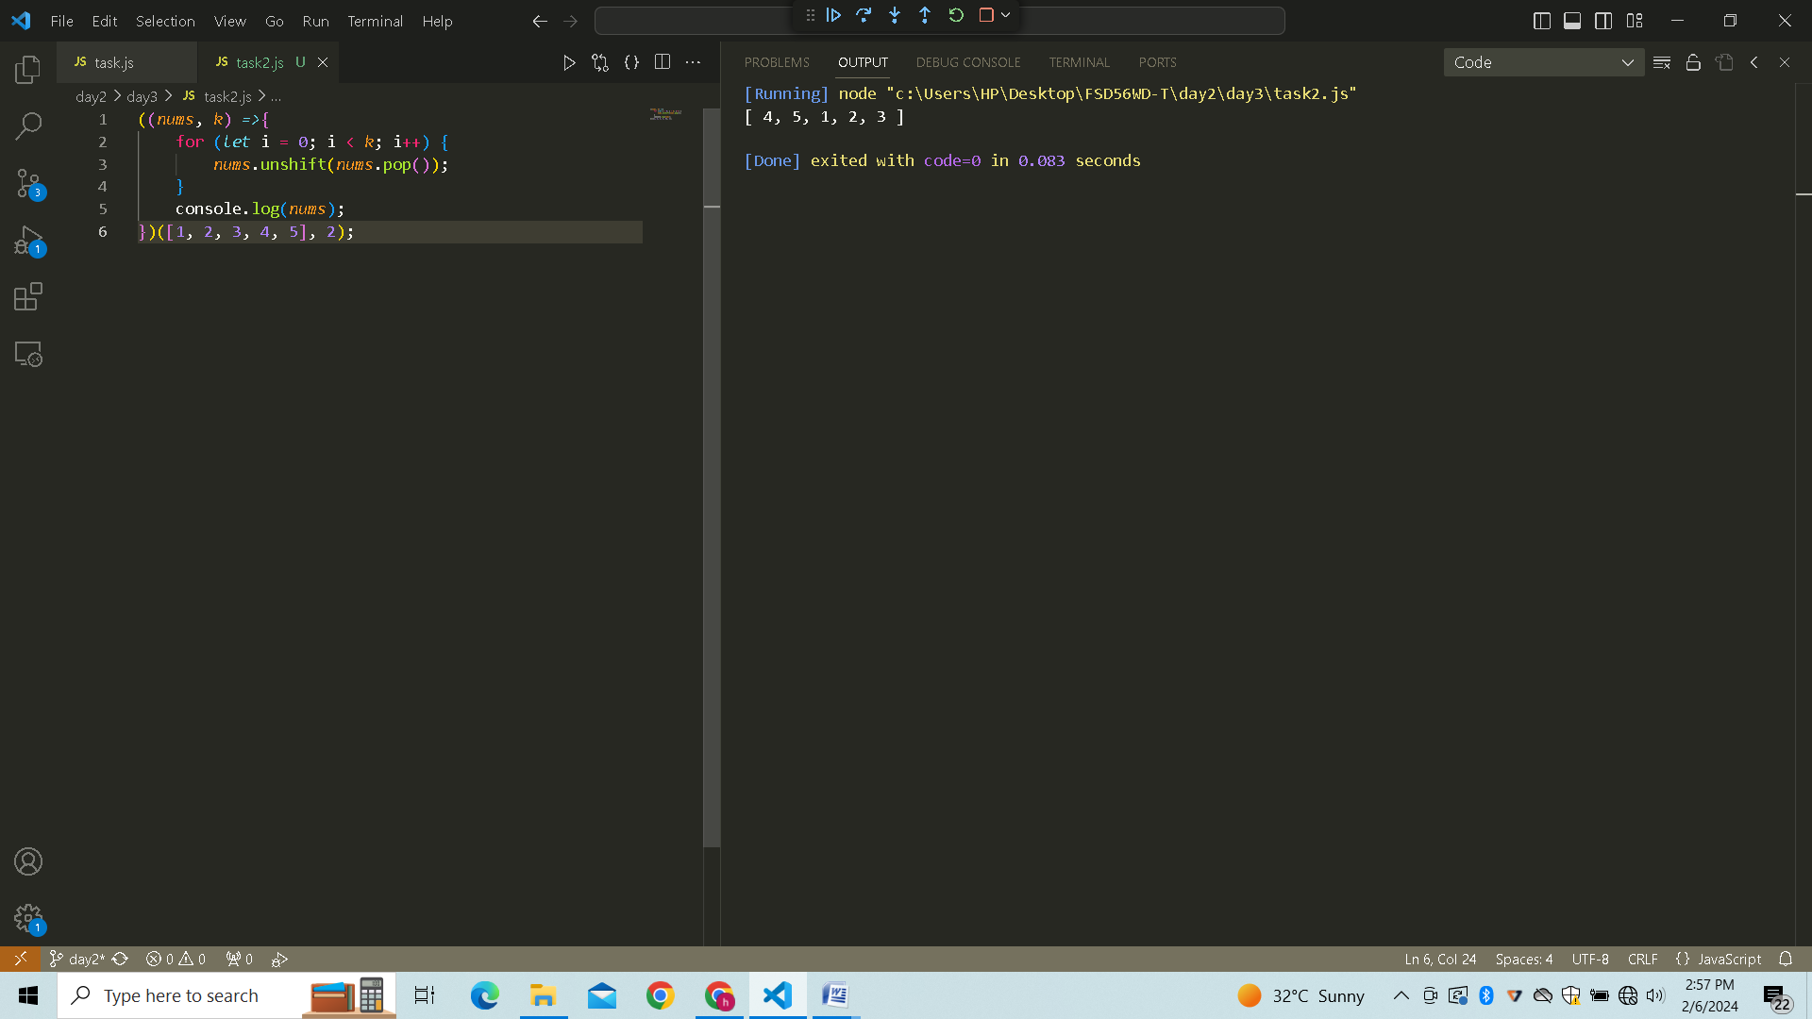

# Program 7:Return all the pallindromes in an array…

console.log((*function*  (*words*){       //used console.log to show output.

*let* panlindromes=[]

    for (word of *words*){

*let* rev =word.split('').reverse().join('');

        if( word == rev){

            panlindromes.push(word);

        }

    }

    return panlindromes;

})(['abc','mom',"picture",'dad']));

# Result :



# Program 8: Return median of two sorted arrays of the same size…

(*function* (*arr1*,*arr2*){

*let* sortedArray = *arr1*.concat(*arr2*);

sortedArray.sort((*a*,*b*)*=>a*-*b*)

console.log(sortedArray);

*let* midNum =sortedArray.length/2;

*let* num1 = sortedArray[midNum-1]

*let* num2 = sortedArray[midNum]

console.log(((num1+num2)/2).toFixed(1));

})

(([1,3,5,7,9]),([2,4,6,8,10]))

# Result:

